# Interface Design & Programming Assignment Report

Lim Pei Sheng 164347E

Nicholas Poh Jun Heng 164353M

## Task Breakdown

|  |  |  |  |
| --- | --- | --- | --- |
| Pei Sheng | | Nicholas | |
| UI task | UI Description | UI task | UI Description |
| Unique Feature (Skills) | Skill Selection from attack button on drag | Account Information | Account ID, Registration, Binding |
| Chat | World, Buddy, Party, Guild Chat | Game Scenes | Login, Account Information, Character, Character Selection, Creation/Deletion |
| Main Game | Game Roadmap(All the UI placement) | Quest | Main, Repeatable, Event |
| Character Information | Inventory, Stats, Skills | Shop | Buy, Sell, Repair, Rebuy |
| World Map | World, Dungeon, Town Map | Options | Video, Audio, Configurations |
|  | | Community | Buddy, Party, Guild |

## Menu Flowchart

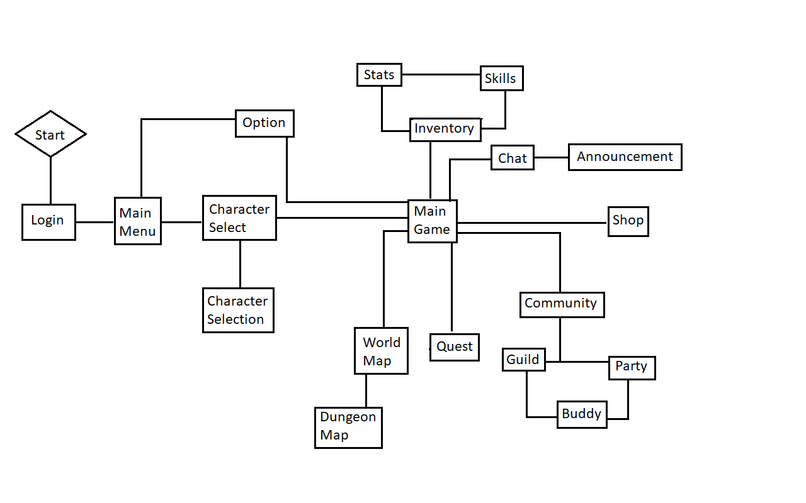

## Game Screen

* User Interface in the game follows the layout of many other RPG games.
* Compact and simple
* Accessible are relative to their purpose;
  + Mini Map -> World map
  + Character Info -> Inventory, Stats, Skills
  + Chat -> Chat overlay & Announcements
  + Tab -> Menu that are not critical

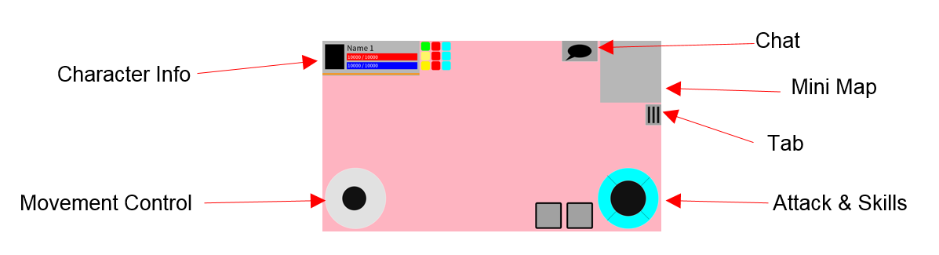

## In-Game examples

|  |
| --- |
| Login Screen  C:\Users\164353M\Desktop\Login.png |
| Account Information  C:\Users\164353M\Desktop\AccountInfo.png |
| Select Character  C:\Users\164353M\Desktop\SelectCharacter.png |

|  |
| --- |
| Create Character  C:\Users\164353M\Desktop\CreateCharacter.png |
| Game Screen  C:\Users\164353M\Desktop\GameScreen.png |
| Character Attack  C:\Users\164353M\Desktop\CharacterAttack.png |

|  |
| --- |
| Player Inventory  C:\Users\164353M\Desktop\Player_Inventory.png |
| Player Profile  C:\Users\164353M\Desktop\Player_Profile.png |
| Player Skill  C:\Users\164353M\Desktop\Player_Skill.png |

|  |
| --- |
| Player Loadout  C:\Users\164353M\Desktop\Player_Loadout.png |
| Chat World  C:\Users\164353M\Desktop\Chat_World.png |
| Chat Proximity  C:\Users\164353M\Desktop\Chat_Proximity.png |

|  |
| --- |
| Map World  C:\Users\164353M\Desktop\Map_World.png |
| Map Town  C:\Users\164353M\Desktop\World_Town.png |
| Quest Main  C:\Users\164353M\Desktop\Quest_Main.png |

|  |
| --- |
| Quest Main 2  C:\Users\164353M\Desktop\Quest_Main2.png |
| Options  C:\Users\164353M\Desktop\Options.png |
| Options 2  C:\Users\164353M\Desktop\Options2.png |

|  |
| --- |
| Shop  C:\Users\164353M\Desktop\Shop.png |
| Shop 2  C:\Users\164353M\Desktop\Shop2.png |